**Operating System**

**(CT-353)**

Lab no 04

**1) Implement the above code and paste the screen shot of the output.**

#include <stdio.h>

int main() {

int buffer[10], bufsize, in, out, produce, consume, choice = 0; in = 0; out = 0; bufsize = 10;

while (choice != 3) {

printf("\n1. Produce \t 2. Consume \t3. Exit"); printf("\nEnter your choice: ");

scanf("%d", &choice);

switch (choice) { case 1:

if ((in + 1) % bufsize == out) printf("\nBuffer is Full"); else {

printf("\nEnter the value: "); scanf("%d", &produce); buffer[in] = produce;

in = (in + 1) % bufsize;

} break;

case 2:

if (in == out)

printf("\nBuffer is Empty"); else {

consume = buffer[out];

printf("\nThe consumed value is %d", consume);

out = (out + 1) % bufsize;

} break;

}

}

}

Output :

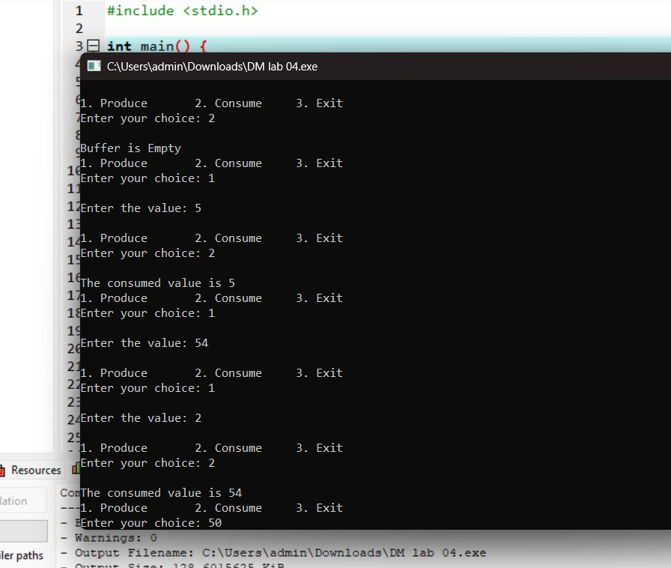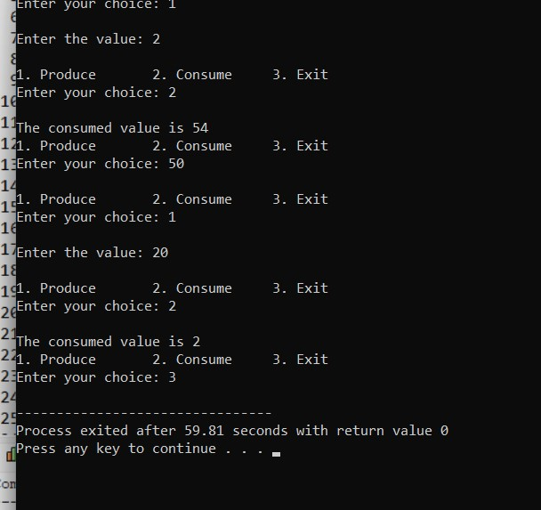

**2) Solve the producer-consumer problem using linked list. Note: Keep the buffer size to 10 places.**

#include <stdio.h>

#define BUFFER_SIZE 10

typedef struct Node { int data;

struct Node* next;

} Node;

Node* head = NULL; Node* tail = NULL; int count = 0;

pthread_mutex_t mutex;

sem_t empty, full;

void insert(int item) {

Node* newNode = (Node*)malloc(sizeof(Node)); newNode->data = item;

newNode->next = NULL;

if (tail == NULL) { head = tail = newNode;

} else {

tail->next = newNode;

tail = newNode;

}

count++;

}

int remove_item() {

if (head == NULL) return -1;

Node* temp = head; int item = temp->data;

head = head->next;

if (head == NULL) tail = NULL;

free(temp); count--; return item;

}

void* producer(void* arg) { int item; while (1) { item = rand() % 100; sem_wait(&empty);

pthread_mutex_lock(&mutex);

insert(item);

printf("Produced: %d\n", item);

pthread_mutex_unlock(&mutex); sem_post(&full);

sleep(1);

}

}

void* consumer(void* arg) {

int item; while (1) { sem_wait(&full);

pthread_mutex_lock(&mutex);

item = remove_item();

printf("Consumed: %d\n", item);

pthread_mutex_unlock(&mutex); sem_post(&empty);

sleep(1);

}

}

int main() {

pthread_t prod, cons;

pthread_mutex_init(&mutex, NULL); sem_init(&empty, 0, BUFFER_SIZE);

sem_init(&full, 0, 0);

pthread_create(&prod, NULL, producer, NULL);

pthread_create(&cons, NULL, consumer, NULL);

pthread_join(prod, NULL);

pthread_join(cons, NULL);

pthread_mutex_destroy(&mutex); sem_destroy(&empty); sem_destroy(&full);

return 0;

}

**Output:**

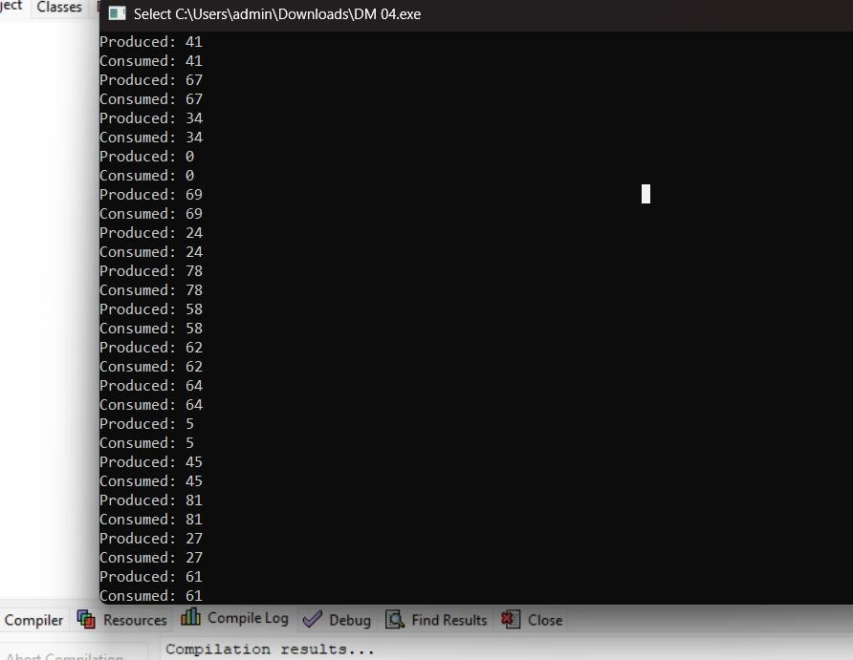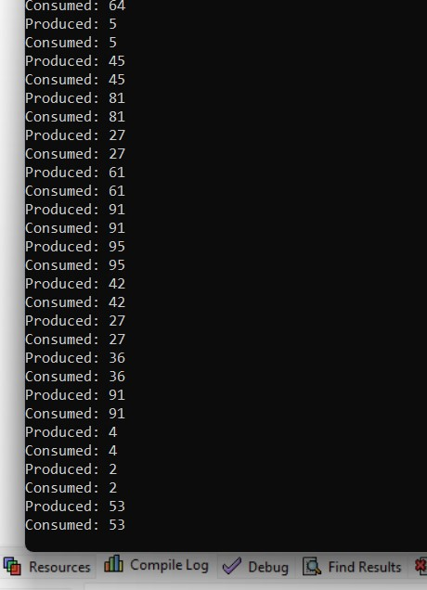

**3) In producer-consumer problem what difference will it make if we utilize stack for the buffer rather than an array?**

Using a stack instead of a queue in the producer-consumer problem fundamentally changes the processing order from FIFO to LIFO, which may not be suitable for many traditional producer-consumer use cases.